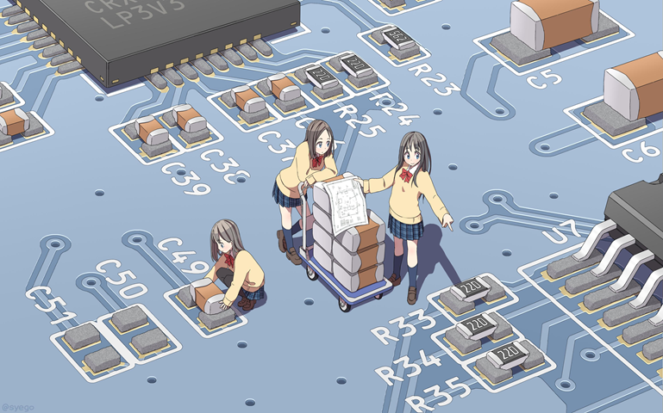

IPV4 BGP LAB

**By Diego Santos**

**Background**

Border Gateway Protocol or BGP for short is a standard gateway protocol created to exchange routing and reachability information among autonomous systems on places like the internet. BGP has been in use on our internet since 1994 and the latest version of BGP (BGP4) has been in use since 2006. There are different kinds of BGP, External BGP and Internal BGP. When BGP is running between two peers within the same system it’s called Internal BGP. The more common BGP is External BGP where BGP is running on two peers that are not within the same system is external BGP which is the BGP we will be using today.

**Purpose**

The Purpose of this Lab is to get two different autonomous systems. One running OSPF and the other side running EIGRP to communicate between each other over BGP. This was all done in ipv4.

**Lab Summary**

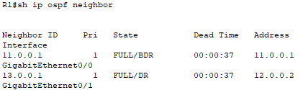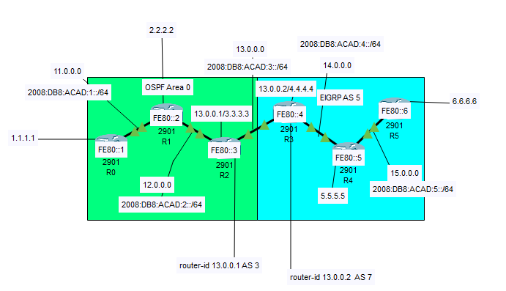First, we set up the initial topology for the Lab using six cisco 2901 routers. Then setting up ipv4 addresses using the template 1#.0.0. # with a /8 subnet mask. With initial setup all up and running we’ll start with OSPF first by enabling OSPF in each router using the (Router OSPF #) with the Process-id that I used being 10. After then setting up router ids as seen above then adding the networks of the first three routers using the (network [network ip][wildcard mask] area [#]) with most common areas being 0 and to make sure that OSPF is running you would use the (show ip ospf neighbor) command to confirm that OSPF is working as seen here. Concluding with the OSPF we’ll move on to EIGRP on the right set of routers. EIGRP isn’t all that different than OSPF first go to all the interfaces that you want to set up EIGRP on and use the (Router eigrp #) command, in this lab I used five. Repeat that for the other routers and move on to the network statements on the interfaces use the (network [network-ip]) on each router. Finally moving onto BGP, first pick out your ASN (Autonomous System Number) in my lab I used 3 and 7 you can’t use the same ASN on the same interface or it will cause the BGP to 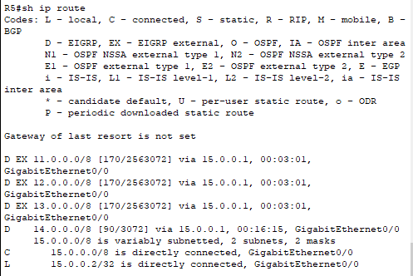not work. To set up BGP on the routers use the command (Network [network ip]). To set up neighbors use the (neighbor {router-id} remote-as {ASN}) command this will be different for each side for the OSPF side use the (redistribute ospf {process id}) then on the EIGRP side in the EIGRP use the command (redistribute bgp 7 metric 1000000 1000 255 20 4) (not sure what the numbers do) to allow the BGP to access the EIGRP and just like that I finished the lab by verifying by using the (sh ip route) command.

**Problems**

I initially had trouble getting the eigrp to show up on the OSPF side, so I used the (redistribute bgp 7 metric 1000000 1000 255 20 4) Command to get it working.

**Conclusion**

In this lab I learned how to set up external BGP with the EIGRP going slightly wrong but working after the command I mention in the problem section.

**Configs**

**Router 0**

hostname R0

ip cef

ipv6 unicast-routing

no ipv6 cef

license udi pid CISCO2901/K9 sn FTX1524317U-

spanning-tree mode pvst

interface GigabitEthernet0/0

ip address 11.0.0.1 255.0.0.0

duplex auto

speed auto

ipv6 address FE80::1 link-local

ipv6 address 2008:DB8:ACAD:1::A/64

ipv6 ospf 20 area 0

interface GigabitEthernet0/1

no ip address

duplex auto

speed auto

shutdown

interface Vlan1

no ip address

shutdown

router ospf 10

router-id 11.0.0.1

log-adjacency-changes

network 11.0.0.0 0.255.255.255 area 0

ipv6 router ospf 20

router-id 1.1.1.1

log-adjacency-changes

ip classless

ip flow-export version 9

**Router 1**

hostname R1

ip cef

ipv6 unicast-routing

no ipv6 cef

license udi pid CISCO2901/K9 sn FTX1524095U-

spanning-tree mode pvst

interface GigabitEthernet0/0

ip address 11.0.0.2 255.0.0.0

duplex auto

speed auto

ipv6 address FE80::2 link-local

ipv6 address 2008:DB8:ACAD:1::B/64

ipv6 ospf 20 area 0

interface GigabitEthernet0/1

ip address 12.0.0.1 255.0.0.0

duplex auto

speed auto

ipv6 address FE80::2 link-local

ipv6 address 2008:DB8:ACAD:2::A/64

ipv6 ospf 20 area 0

interface Vlan1

no ip address

shutdown

router ospf 10

router-id 12.0.0.1

log-adjacency-changes

network 11.0.0.0 0.255.255.255 area 0

network 12.0.0.0 0.255.255.255 area 0

ipv6 router ospf 20

router-id 2.2.2.2

log-adjacency-changes

**Router 2**

hostname R2

ip cef

ipv6 unicast-routing

no ipv6 cef

license udi pid CISCO2901/K9 sn FTX1524J2ZV-

spanning-tree mode pvst

interface GigabitEthernet0/0

ip address 13.0.0.1 255.0.0.0

duplex auto

speed auto

ipv6 address FE80::3 link-local

ipv6 address 2008:DB8:ACAD:3::A/64

interface GigabitEthernet0/1

ip address 12.0.0.2 255.0.0.0

duplex auto

speed auto

ipv6 address FE80::3 link-local

ipv6 address 2008:DB8:ACAD:2::B/64

ipv6 ospf 20 area 0

interface Vlan1

no ip address

shutdown

router ospf 10

router-id 13.0.0.1

log-adjacency-changes

redistribute bgp 3 metric 3 subnets

network 12.0.0.0 0.255.255.255 area 0

router bgp 3

bgp log-neighbor-changes

no synchronization

neighbor 13.0.0.2 remote-as 7

network 13.0.0.0

redistribute ospf 10

ipv6 router ospf 20

router-id 3.3.3.3

log-adjacency-changes

ip classless

ip flow-export version 9

**Router 3**

hostname R3

ip cef

ipv6 unicast-routing

no ipv6 cef

license udi pid CISCO2901/K9 sn FTX1524M49Z-

spanning-tree mode pvst

interface GigabitEthernet0/0

ip address 13.0.0.2 255.0.0.0

duplex auto

speed auto

ipv6 address FE80::4 link-local

ipv6 address 2008:DB8:ACAD:3::B/64

interface GigabitEthernet0/1

ip address 14.0.0.1 255.0.0.0

duplex auto

speed auto

ipv6 address FE80::4 link-local

ipv6 address 2008:DB8:ACAD:4::A/64

ipv6 eigrp 6

ipv6 enable

interface Vlan1

no ip address

shutdown

router eigrp 5

redistribute bgp 7 metric 1000000 1000 255 20 4

network 14.0.0.0

network 15.0.0.0

router bgp 7

bgp log-neighbor-changes

no synchronization

neighbor 13.0.0.1 remote-as 3

network 13.0.0.0

redistribute eigrp 5

ipv6 router eigrp 6

eigrp router-id 4.4.4.4

no shutdown

ip classless

ip flow-export version 9

**Router 4**

hostname R4

ip cef

ipv6 unicast-routing

no ipv6 cef

license udi pid CISCO2901/K9 sn FTX1524970I-

spanning-tree mode pvst

interface GigabitEthernet0/0

ip address 15.0.0.1 255.0.0.0

duplex auto

speed auto

ipv6 address FE80::5 link-local

ipv6 address 2008:DB8:ACAD:5::A/64

ipv6 eigrp 6

ipv6 enable

interface GigabitEthernet0/1

ip address 14.0.0.2 255.0.0.0

duplex auto

speed auto

ipv6 address FE80::5 link-local

ipv6 address 2008:DB8:ACAD:4::B/64

ipv6 eigrp 6

ipv6 enable

interface Vlan1

no ip address

shutdown

router eigrp 5

network 15.0.0.0

network 14.0.0.0

ipv6 router eigrp 6

eigrp router-id 5.5.5.5

no shutdown

ip classless

ip flow-export version 9

**Router 5**

hostname R5

ip cef

ipv6 unicast-routing

no ipv6 cef

license udi pid CISCO2901/K9 sn FTX152402YH-

spanning-tree mode pvst

interface GigabitEthernet0/0

ip address 15.0.0.2 255.0.0.0

duplex auto

speed auto

ipv6 address FE80::6 link-local

ipv6 address 2008:DB8:ACAD:5::B/64

ipv6 eigrp 6

ipv6 enable

interface GigabitEthernet0/1

no ip address

duplex auto

speed auto

shutdown

interface Vlan1

no ip address

shutdown

router eigrp 5

network 15.0.0.0

ipv6 router eigrp 6

eigrp router-id 6.6.6.6

no shutdown

ip classless

ip flow-export version 9